1. Connect to Real-Time hub in Microsoft Fabrics  
   A close up of a logo

   AI-generated content may be incorrect.  
   A screenshot of a computer

   AI-generated content may be incorrect.
2. Fabrics Event  
   A screenshot of a computer

   AI-generated content may be incorrect.
3. Azure Events   
   A screenshot of a computer

   AI-generated content may be incorrect.
4. Create a workspace BikesRTAnalytics  
   A screenshot of a computer

   AI-generated content may be incorrect.
5. Add new Event house  
   A screenshot of a computer

   AI-generated content may be incorrect.
6. That gives me a KQL database environment and I can create more if required  
   A screenshot of a computer

   AI-generated content may be incorrect.
7. I can view all activities of my databases  
   A screenshot of a computer

   AI-generated content may be incorrect.
8. Select the Database and we have below options  
   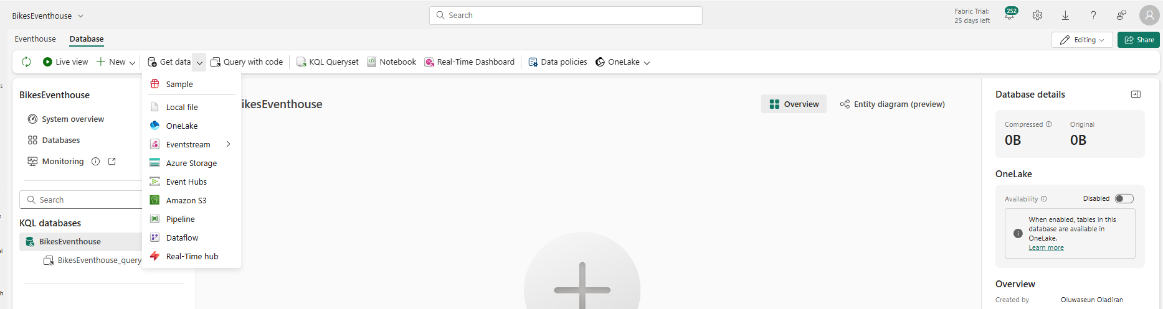
9. By default event database datasets are not in one lake but can be made available  
   A screenshot of a computer

   AI-generated content may be incorrect.
10. Back to the workspace and create event stream  
    A screenshot of a computer

    AI-generated content may be incorrect.
11. Then we can design a flow to ingest from available data sources  
    A screenshot of a computer

    AI-generated content may be incorrect.
12. Multiple data sources available  
    A screenshot of a computer

    AI-generated content may be incorrect.
13. Using sample data  
    A screenshot of a computer

    AI-generated content may be incorrect.
14. Then it connect automatically to the data source  
    A screenshot of a computer

    AI-generated content may be incorrect.
15. We can transform the event  
    A screenshot of a computer

    AI-generated content may be incorrect.
16. And we can send transformed data to a destination  
    A screenshot of a computer

    AI-generated content may be incorrect.
17. Here we send to event house previously created, fill the credentials and create a table  
    A screenshot of a computer

    AI-generated content may be incorrect.
18. Save and publish event stream  
    A screenshot of a computer

    AI-generated content may be incorrect.
19. Now the table is available in the BikesEventhous KQL database (Refresh to see the update)  
    A screenshot of a computer

    AI-generated content may be incorrect.
20. KQL queryset provided guidance on how to use the environment~  
    A screenshot of a computer

    AI-generated content may be incorrect.  
    SQL to KQL [Link](https://learn.microsoft.com/en-us/kusto/query/sql-cheat-sheet?view=azure-data-explorer&preserve-view=true&context=%2Ffabric%2Fcontext%2Fcontext)  
    KQL Quick reference [Link](https://learn.microsoft.com/en-us/kusto/query/kql-quick-reference?view=azure-data-explorer&preserve-view=true&context=%2Ffabric%2Fcontext%2Fcontext)
21. Run quick query on the table  
    A screenshot of a computer

    AI-generated content may be incorrect.
22. I can use Explain (SQL query) this converts the SQL to KQL and I can copy and run the KQL  
    A screen shot of a computer

    AI-generated content may be incorrect.
23. The Query becomes  
    A screenshot of a computer

    AI-generated content may be incorrect.
24. We can get table schema using the script below  
    A screenshot of a computer

    AI-generated content may be incorrect.
25. Get specific columns from the schema using project  
    A screenshot of a computer

    AI-generated content may be incorrect.
26. We can create the Bronze table with the script below  
    A screenshot of a computer

    AI-generated content may be incorrect.
27. Transform Event stream data an add timestamp using Managefields  
    A screenshot of a computer

    AI-generated content may be incorrect.  
    A screenshot of a chat

    AI-generated content may be incorrect.
28. Link to the Event house to have below  
    A screenshot of a chat

    AI-generated content may be incorrect.
29. Under the manage fields settings add all existing columns and system time stamp  
    A screenshot of a computer

    AI-generated content may be incorrect.  
    A screenshot of a computer

    AI-generated content may be incorrect.
30. After adding the field add all fieldA screenshot of a computer

    AI-generated content may be incorrect.
31. It yields this   
    A screenshot of a chat

    AI-generated content may be incorrect.
32. Refresh to see new dataset at the Managefield  
    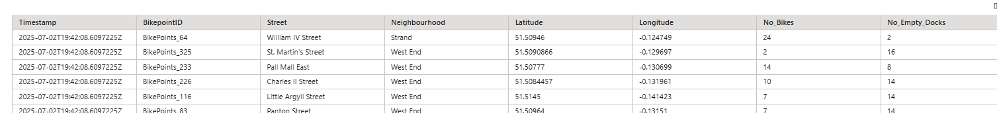
33. Also refresh the Event house view also   
    A screenshot of a computer

    AI-generated content may be incorrect.
34. Publish event stream once done  
      
    A screenshot of a computer

    AI-generated content may be incorrect.
35. Add the Timestamp field to the Bronze table  
    A screenshot of a computer

    AI-generated content may be incorrect.  
    A screenshot of a computer

    AI-generated content may be incorrect.
36. Using set-or-replace  
    A screenshot of a computer

    AI-generated content may be incorrect.
37. Create a function that Clean the data and place the result in the Silver folder  
    A computer screen shot of text

    AI-generated content may be incorrect.

1. The result in function folder  
   A close up of a arrow

   AI-generated content may be incorrect.
2. Create a Table update policy on BikeRaw data to update silver table from the Bikeseventhouse  
   A screenshot of a computer

   AI-generated content may be incorrect.
3. It creates the query template just put your parameters  
   A screenshot of a computer

   AI-generated content may be incorrect.
4. This does not accept multiple line query hence I wrap the query in a function

1. Run the update policy  
   
2. Move biketransformed table to silver folder  
   A screenshot of a computer

   AI-generated content may be incorrect.
3. Create a Materialized view for the Gold layer, because here refresh is automatic based on the tables used  
   A screenshot of a computer

   AI-generated content may be incorrect.
4. Visualize dataset below  
   A screenshot of a computer

   AI-generated content may be incorrect.
5. Pin to dashboard using the icon  
   A screenshot of a computer

   AI-generated content may be incorrect.
6. This gives the report   
   A screenshot of a computer

   AI-generated content may be incorrect.
7. We can add a new tile in edit mode get all Chelsea Neighbourhood bikes  
   A screenshot of a computer

   AI-generated content may be incorrect.
8. The updated visuals becomes  
   A screenshot of a computer

   AI-generated content may be incorrect.
9. Add a new tile to show maximum number of tiles available in Chelsea  
   A screenshot of a computer

   AI-generated content may be incorrect.
10. Use the Longitude and Latitude to create a map  
    A screenshot of a computer

    AI-generated content may be incorrect.
11. Use Maps and configure the latitude and longitude  
    A screenshot of a map

    AI-generated content may be incorrect.
12. The report becomes  
    A screenshot of a computer

    AI-generated content may be incorrect.
13. We can setup auto refresh under manage  
    A screenshot of a computer

    AI-generated content may be incorrect.
14. Select refresh option  
    A screenshot of a phone

    AI-generated content may be incorrect.
15. You can set alert  
    A screenshot of a computer

    AI-generated content may be incorrect.
16. When max number of available bikes is Lessthan 5   
    A screenshot of a computer

    AI-generated content may be incorrect.
17. Configure the action Send an email or message in teams  
    A screenshot of a computer

    AI-generated content may be incorrect.
18. Create a new activator alert  
    A screenshot of a computer screen

    AI-generated content may be incorrect.
19. Alert created   
    A screenshot of a computer

    AI-generated content may be incorrect.
20. To create a derived stream only for specific region  
    Go to the event stream Edit the stream by adding a filter

Add a stream destination

Create a filter and add Stream as a destination

Add Activator to triger action based on rawbike activities

1. Working on the eventstream add a new rule  
   A screenshot of a computer

   AI-generated content may be incorrect.
2. A screenshot of a computer

   AI-generated content may be incorrect.
3. A screenshot of a computer

   AI-generated content may be incorrect.
4. I can stop the Alert  
   A screenshot of a computer

   AI-generated content may be incorrect.
5. We can define the workflow by adding task to the workspace  
   A screenshot of a computer

   AI-generated content may be incorrect.
6. The Whole workflow becomes  
   A screenshot of a computer

   AI-generated content may be incorrect.
7. We ingested Bikesdata data from event stream, keep in event house and KQL database, move through layers, created materialize view for the gold layer, and created visual tiles
8. Activator Alert  
   A screenshot of a computer

   AI-generated content may be incorrect.
9. Eventhouse report  
   A screenshot of a computer

   AI-generated content may be incorrect.